**KO Hŭi-dong (고희동, 高羲東, 1886-1965)**

Ko Hŭi-dong is regarded as Korea’s first Western-style painter. Born into a progressive diplomatic family, Ko studied at a French language school in Seoul, where he was introduced to Western culture and art by his French teachers and artists such as Léopold Remion. Ko became a government official, but throughout his career grew concerned with what he saw as the decline of his country. In response, he turned to traditional ink painting, studying under the country’s last court painters, An Chung-sik (안중식, 安中植, 1853-1920) and Cho Sŏk-chin (1816-1919). Ko eventually came to see traditional ink painting as little more than a copy of Chinese painting, so in 1909, the year before the Japanese colonisation of Korea, Ko went to Tokyo. There he studied Western-style painting at the Tokyo School of Fine Arts under Kuroda Seiki (조석진, 趙錫晉, 1866-1924). However, as is obvious in the large number of his remaining landscapes, Eastern-style ink painting eventually became Ko's focus, where he applied his expertise in Western painting techniques to this traditional Asian medium. The unconventional content and new perspectives in landscape that resulted are the basis of Ko's reputation as a founder of the modern ink painting style. Ko was also an art educator and administrator, and one of the most influential leaders in Korean modern art history.

After he graduated from the Tokyo School of Fine Arts in 1915, Ko returned to Seoul and continued to paint. Among his surviving oil paintings are three self-portraits that present him in various traditional Korean costumes. One showing the artist holding a fan, wearing an open-buttoned summer shirt, and posed in front of a bookshelf with a painting on the wall behind suggests his awareness of himself as a modern intellectual painter.

Ko taught art in many high schools in Seoul, and opened Koryŏ Painting Studio at the YMCA in 1919. Most importantly, Ko established The School of Painting and Calligraphy (*Sŏhwa Hyŏphoe*) in 1918, gathering together his teachers, An Chung-sik and Cho Sŏk-chin, who were nationalistic Korean painters and calligraphers. As the first modern artist group in Korea, The School of Painting and Calligraphy, sought to find a more Korean form of artistic expression in order to counterbalance the impact of Western-style artists returning from Japan who were represented in the state-sponsored Chosŏn Art Exhibition. The School of Painting and Calligraphy began annual exhibitions in 1921, holding exhibitions until 1937 when the group was dispersed by the colonial government.

After the Liberation of Korea from Japan in 1945, Ko continued to make ink paintings and exhibit them in group and solo exhibitions. He became Chairman of The Korean Art Society and between 1949 and 1959, organized the National Art Exhibition and served as one of its jurors. Ko was also elected a member of the National Assembly in 1960.

**References and Further Reading**

Kim, Youngna. (1998) ‘Modern Korean painting and sculpture,’ in John Clark, ed. *Modern Asian Art*. Honolulu: University of Hawai’i Press, 155-168.

Kim, Youngna. (2005) *Modern and Contemporary Art in Korea*. Elizabeth (NJ): Hollym International Corp.

Lee, Jungsil. (2011) ‘Reconsidering the Body in Korean Modern Art: Ku Ponung’s Body, World, and Art,’ Ph.D. Dissertation, UCLA.

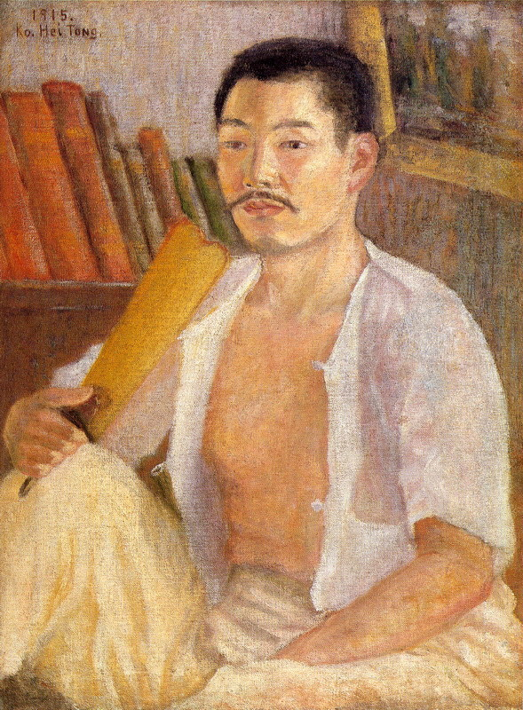

Ko Hŭi-dong, *Self-portrait holding a fan*, 1915, Oil on Canvas, 61x46cm, National Museum of Contemporary Art, Korea.

http://www.mmca.go.kr/html/item/item_image.jsp?artwork_image=PA_00126.jpg